Here's a comprehensive digital marketing strategy for Haldiram's:

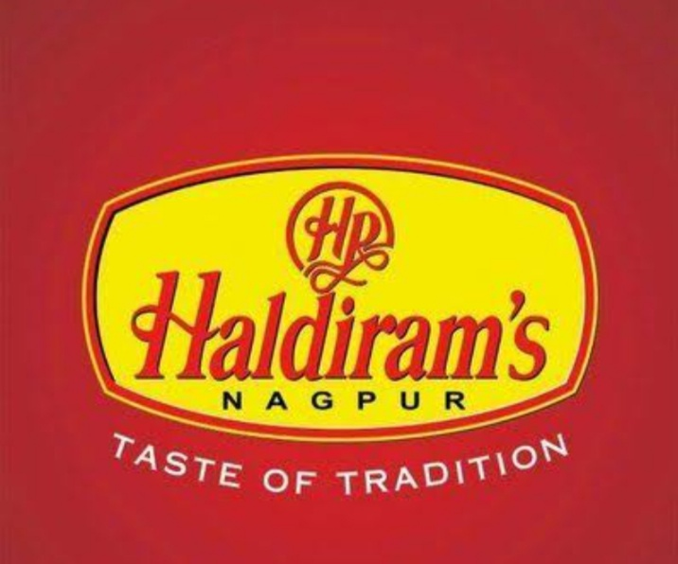

\*Brand Study:\*

Haldiram's is a well-established Indian sweets and snacks brand with a rich history dating back to 1937. The brand is known for its high-quality products, traditional recipes, and iconic packaging.

\*Competitor Analysis:\*

Key competitors:

1. Bikanervala

2. MTR Foods

3. Britannia Industries

4. Parle Products

Competitor strengths and weaknesses:

1. Bikanervala: Strong online presence, wide distribution network

Weakness: Limited product portfolio

2. MTR Foods: Innovative products, strong brand recognition

Weakness: Limited online presence

3. Britannia Industries: Strong brand recognition, wide distribution network

Weakness: Limited product portfolio in traditional sweets and snacks

4. Parle Products: Strong brand recognition, wide distribution network

Weakness: Limited product portfolio in traditional sweets and snacks

\*Buyer Audience Persona Research:\*

Target audience:

1. Demographics: Middle-aged individuals, families with young children

2. Psychographics: Traditional, health-conscious, foodies

3. Pain points: Difficulty finding authentic, high-quality traditional sweets and snacks

4. Goals: To indulge in delicious, traditional sweets and snacks while maintaining a healthy lifestyle

5. Preferred communication channels: Social media, email, online advertising

\*Digital Marketing Strategy:\*

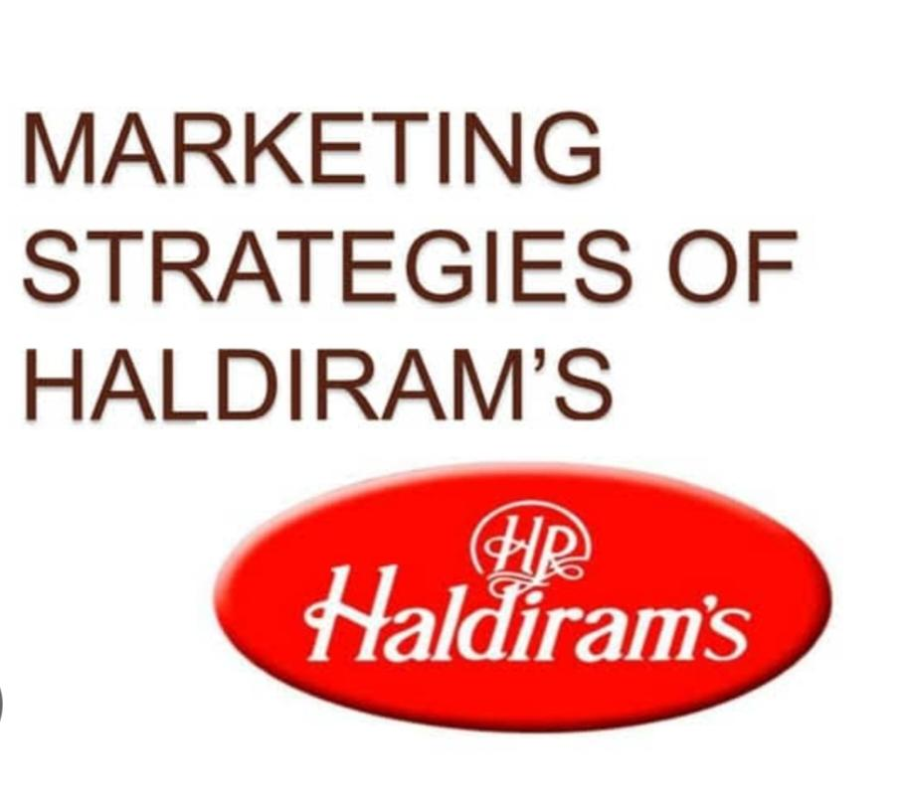

1. \*Website:\* Revamp the existing website to provide a seamless user experience, easy navigation, and a comprehensive product catalog.

2. \*Social Media:\*

- Facebook: Share engaging content, promotions, and events to increase brand awareness and drive sales.

- Instagram: Showcase products, share behind-the-scenes content, and collaborate with influencers to increase brand visibility.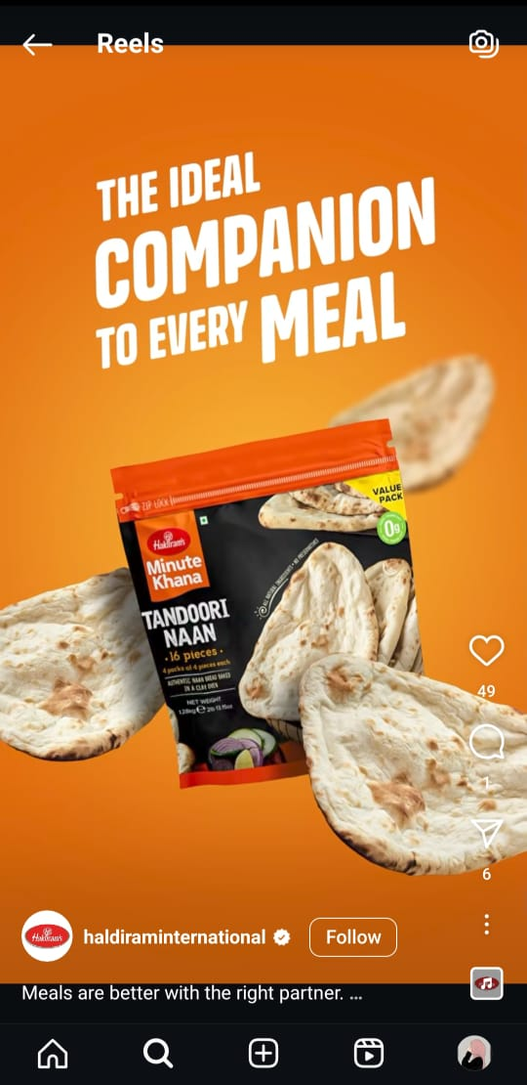

- Twitter: Share quick updates, promotions, and engage with customers to build brand loyalty.

3. \*Email Marketing:\* Send regular newsletters to subscribers showcasing new products, promotions, and events to drive sales and increase brand engagement.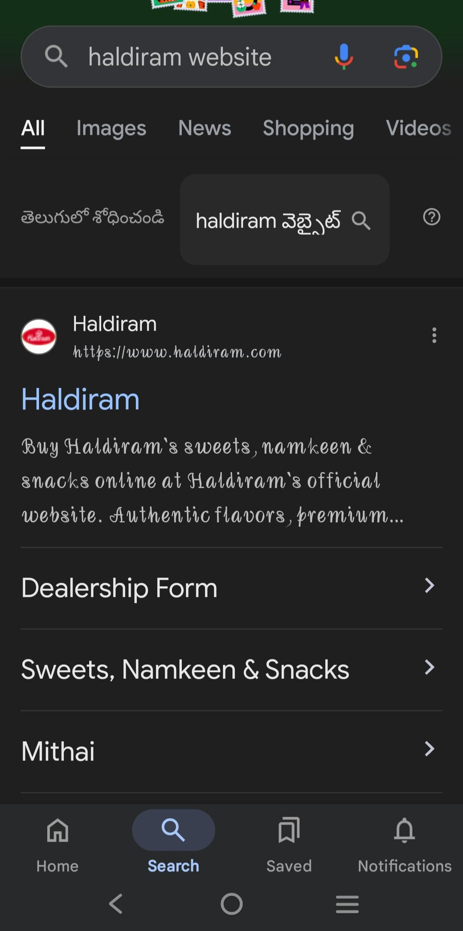

4. \*Influencer Marketing:\* Collaborate with social media influencers and bloggers in the food and beverage industry to promote Haldiram's products and increase brand visibility.

5. \*Content Marketing:\* Create engaging content (blog posts, videos, infographics) showcasing traditional recipes, product benefits, and brand stories to increase brand awareness and drive sales.

6. \*Paid Advertising:\* Run targeted online ads (Google Ads, Facebook Ads) to increase brand visibility, drive website traffic, and generate sales.

7. \*Search Engine Optimization (SEO):\* Optimize the website and online content to improve search engine rankings, increase website traffic, and drive sales.

\*Budget Allocation:\*

1. Website revamp: 20%

2. Social media marketing: 25%

3. Email marketing: 10%

4. Influencer marketing: 15%

5. Content marketing: 10%

6. Paid advertising: 20%

\*Timeline:\*

Quarter 1 (January-March): Website revamp, social media setup, and content creation

Quarter 2 (April-June): Launch influencer marketing campaign, email marketing campaign, and paid advertising

Quarter 3 (July-September): Analyze results, optimize campaigns, and plan for festive season promotions

Quarter 4 (October-December): Execute festive season promotions, launch new products, and review year-end performanceBhai, zaroor

Haldiram's Background

1. \*History\*: Haldiram's was founded in 1937 by Ganga Ram Agrawal.

2. \*Products\*: Haldiram's offers a wide range of traditional Indian sweets, snacks, and beverages.

3. \*Target Audience\*: Haldiram's targets Indian families, youngsters, and individuals who crave traditional Indian sweets and snacks.

Content Creation

1. \*Product Descriptions\*: Write detailed and mouth-watering product descriptions for Haldiram's website.

2. \*Recipes\*: Create and share recipes that feature Haldiram's products.

3. \*Blog Posts\*: Write informative blog posts about Indian sweets, snacks, and beverages.

4. \*Videos\*: Produce high-quality videos that showcase Haldiram's products, cooking processes, and customer testimonials.

Social Media Content Calendar

1. \*Facebook\*: Share promotional posts, events, and updates.

2. \*Instagram\*: Share visually appealing images and videos of Haldiram's products.

3. \*Twitter\*: Share quick updates, promotions, and engage with customers.

4. \*YouTube\*: Share recipe videos, product reviews, and customer testimonials.

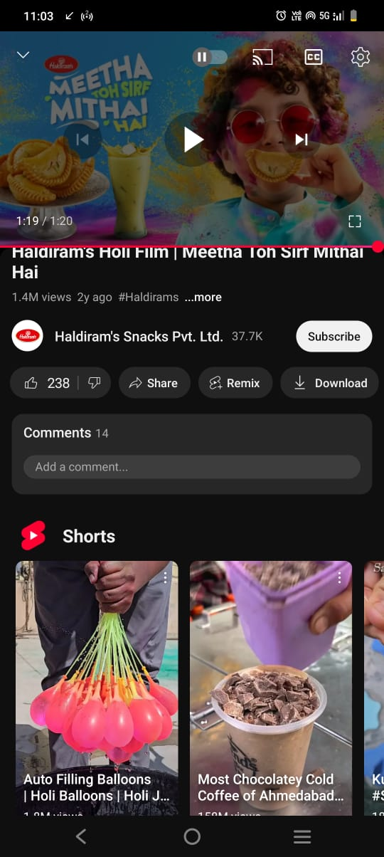

Email Marketing Campaigns

1. \*Welcome Email\*: Send a welcome email to new subscribers with exclusive offers and discounts.

2. \*Promotional Emails\*: Send regular promotional emails with new product launches, offers, and discounts.

3. \*Abandoned Cart Emails\*: Send reminders to customers who have abandoned their shopping carts.

Budget Allocation

1. \*Social Media\*: Allocate 30% of the budget to social media marketing.

2. \*Content Creation\*: Allocate 20% of the budget to content creation.

3. \*Influencer Marketing\*: Allocate 15% of the budget to influencer marketing.

4. \*Paid Advertising\*: Allocate 25% of the budget to paid advertising.

5. \*Email Marketing\*: Allocate 10% of the budget to email marketing.Bhai, let's dive deeper into each category.



Digital Marketing Strategy

1. \*Social Media Marketing\*: Creating and implementing a social media strategy to increase brand awareness, engagement, and sales.

2. \*Email Marketing\*: Building and sending targeted email campaigns to subscribers to promote products, offers, and events.

3. \*Influencer Marketing\*: Partnering with influencers to promote Haldiram's products to their followers.

4. \*Content Marketing\*: Creating and distributing valuable, relevant, and consistent content to attract and retain a clearly defined audience.

5. \*Paid Advertising\*: Running paid ads on Google, Facebook, Instagram, and other platforms to reach a wider audience.

Content Creation

1. \*Blog Posts\*: Writing informative and engaging articles about Haldiram's products, recipes, and Indian cuisine.

2. \*Social Media Posts\*: Creating and scheduling social media posts, including images, videos, and captions.

3. \*Email Newsletters\*: Designing and sending regular newsletters to subscribers showcasing Haldiram's products, offers, and events.

4. \*Video Content\*: Producing high-quality video content, such as recipe videos, product reviews, and behind-the-scenes stories.

5. \*Infographics\*: Creating visually appealing infographics highlighting Haldiram's products, recipes, and nutritional information.

Haldiram-Specific Topics

1. \*Product Showcases\*: Highlighting Haldiram's products, including images, descriptions, and nutritional information.

2. \*Recipe Content\*: Creating and sharing recipes that feature Haldiram's products.

3. \*Behind-the-Scenes Stories\*: Sharing stories about Haldiram's history, manufacturing process, and employees.

4. \*Customer Testimonials\*: Sharing customer reviews, ratings, and testimonials about Haldiram's products.

5. \*Brand History and Legacy\*: Sharing Haldiram's rich history, legacy, and cultural significance.

Technical and Analytics

1. \*Website Optimization\*: Ensuring Haldiram's website is user-friendly, fast, and optimized for search engines.

2. \*SEO\*: Improving Haldiram's website's search engine ranking through keyword research, on-page optimization, and link building.

3. \*Google Analytics\*: Tracking and analyzing website traffic, engagement, and conversion rates.

4. \*Social Media Analytics\*: Monitoring and analyzing social media performance, including engagement rates, reach, and clicks.

5. \*Email Marketing Metrics\*: Tracking and analyzing email marketing performance, including open rates, click-through rates, and conversion rates.

Here's a comprehensive content creation and SEO strategy for Haldiram:



Content Creation Strategy

\*1. Blog Posts\*

1. \*Recipe Blog Posts\*: Share traditional Indian recipes featuring Haldiram products.

2. \*Food Blog Posts\*: Write about Indian cuisine, food trends, and cultural significance.

3. \*Lifestyle Blog Posts\*: Create content around health, wellness, and entertainment.

\*2. Social Media Content\*

1. \*Product Showcase\*: Share high-quality product images and videos.

2. \*Behind-the-Scenes\*: Give sneak peeks into Haldiram's manufacturing process, events, and company culture.

3. \*User-Generated Content\*: Encourage customers to share photos or videos of them enjoying Haldiram products.

\*3. Video Content\*

1. \*Recipe Videos\*: Create step-by-step recipe videos featuring Haldiram products.

2. \*Product Review Videos\*: Showcase product features, benefits, and customer testimonials.

3. \*Brand Story Videos\*: Share Haldiram's history, mission, and values.

\*4. Influencer Content\*

1. \*Partnerships\*: Collaborate with social media influencers, food bloggers, and Indian cuisine experts.

2. \*Sponsored Content\*: Partner with influencers to create sponsored content featuring Haldiram products.

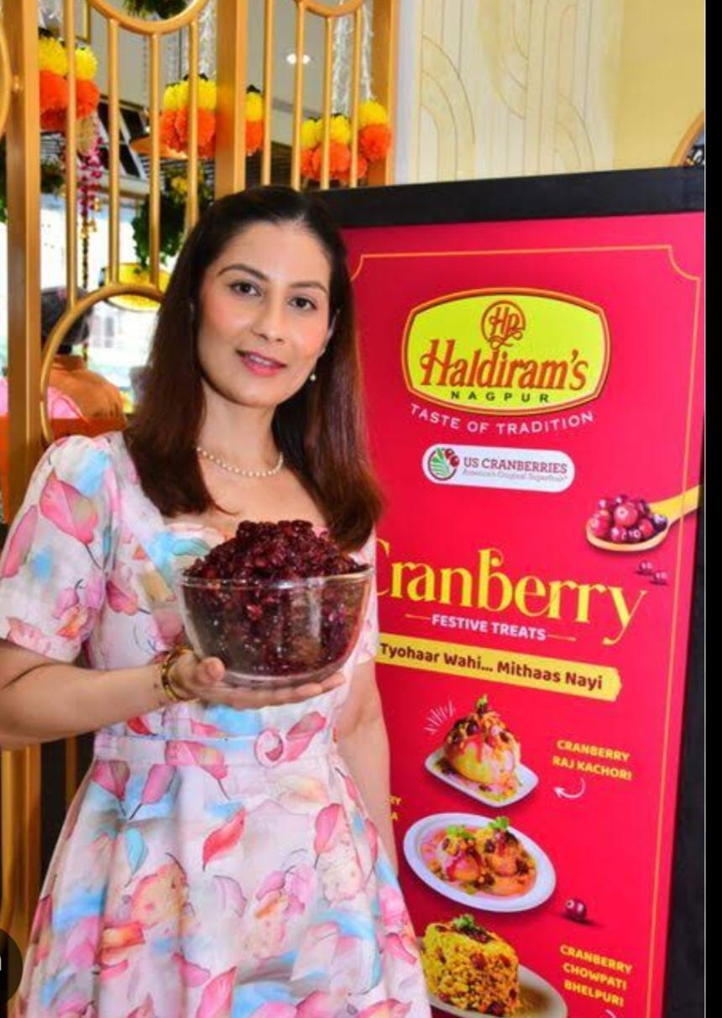

Performance Metrics

1. Website traffic

2. Search engine rankings (SERPs)

3. Social media engagement metrics (likes, shares, comments)

4. Conversion rates (sales, leads, etc.)

5. Keyword rankings and impressions

By implementing this comprehensive content creation and SEO strategy, Haldiram can:

1. Enhance its online presence and visibility.

2. Drive more website traffic and sales.

3. Establish itself as a thought leader in the Indian snack food industry.

4. Improve its search engine rankings and keyword visibility.

here are some content creation ideas for Haldiram:

Recipe Videos

1. "Haldiram's Secret Recipes" series, showcasing traditional Indian snacks with a twist.

2. "Fusion Feasts" series, combining Haldiram's products with international cuisines.

Behind-the-Scenes

1. "A Day in the Life" vlog, showcasing Haldiram's manufacturing process.

2. "Meet the Makers" series, highlighting the artisans and chefs behind Haldiram's products.

User-Generated Content

1. "Haldiram's Snack Attack" contest, encouraging customers to share their favorite Haldiram's snacks.

2. "Haldiram's Recipe Contest" series, inviting customers to share their own recipes using Haldiram's products.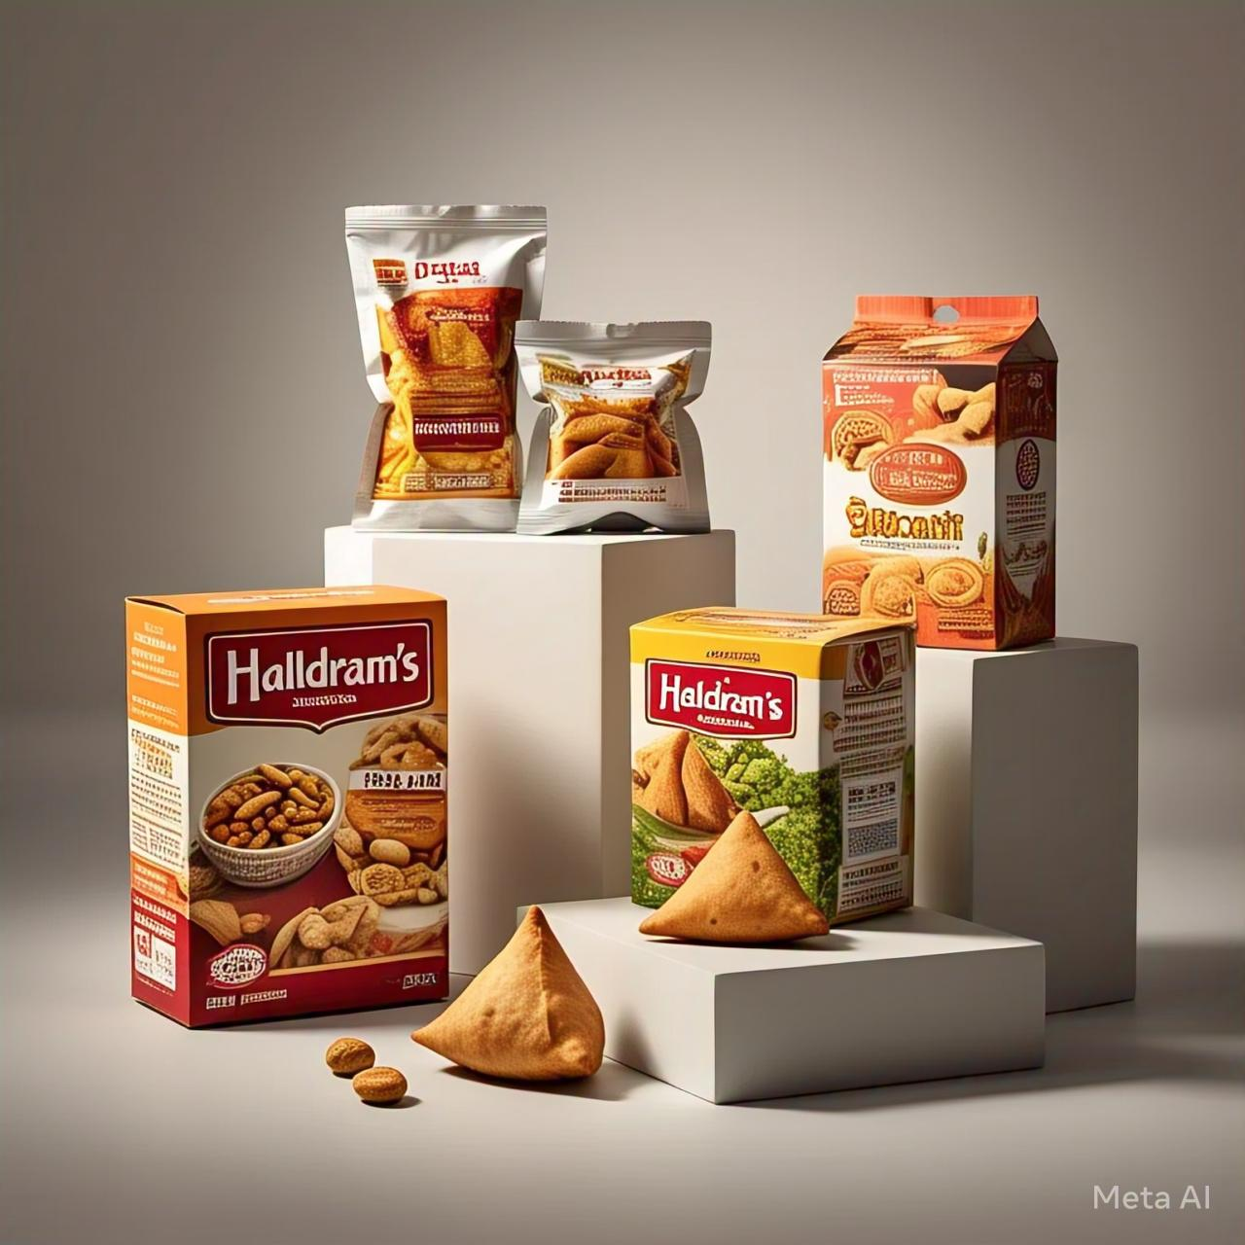

Seasonal and Festive Content

1. "Diwali Delights" series, showcasing Haldiram's festive offerings.

2. "Holi Hai" series, highlighting colorful and fun recipes using Haldiram's products.

Influencer Collaborations

1. Partner with social media influencers and food bloggers to showcase Haldiram's products.

2. Collaborate with Indian celebrities to promote Haldiram's brand.

Educational Content

1. "The Story of Indian Snacks" series, highlighting the history and cultural significance of Indian snacks.

2. "Snack Smart" series, providing health and nutrition tips related to snacking.

Interactive Content

1. "Haldiram's Quiz" series, testing customers' knowledge about Indian snacks and Haldiram's products.

2. "Haldiram's Polls" series, asking customers for their opinions on new products or flavors.

Video Content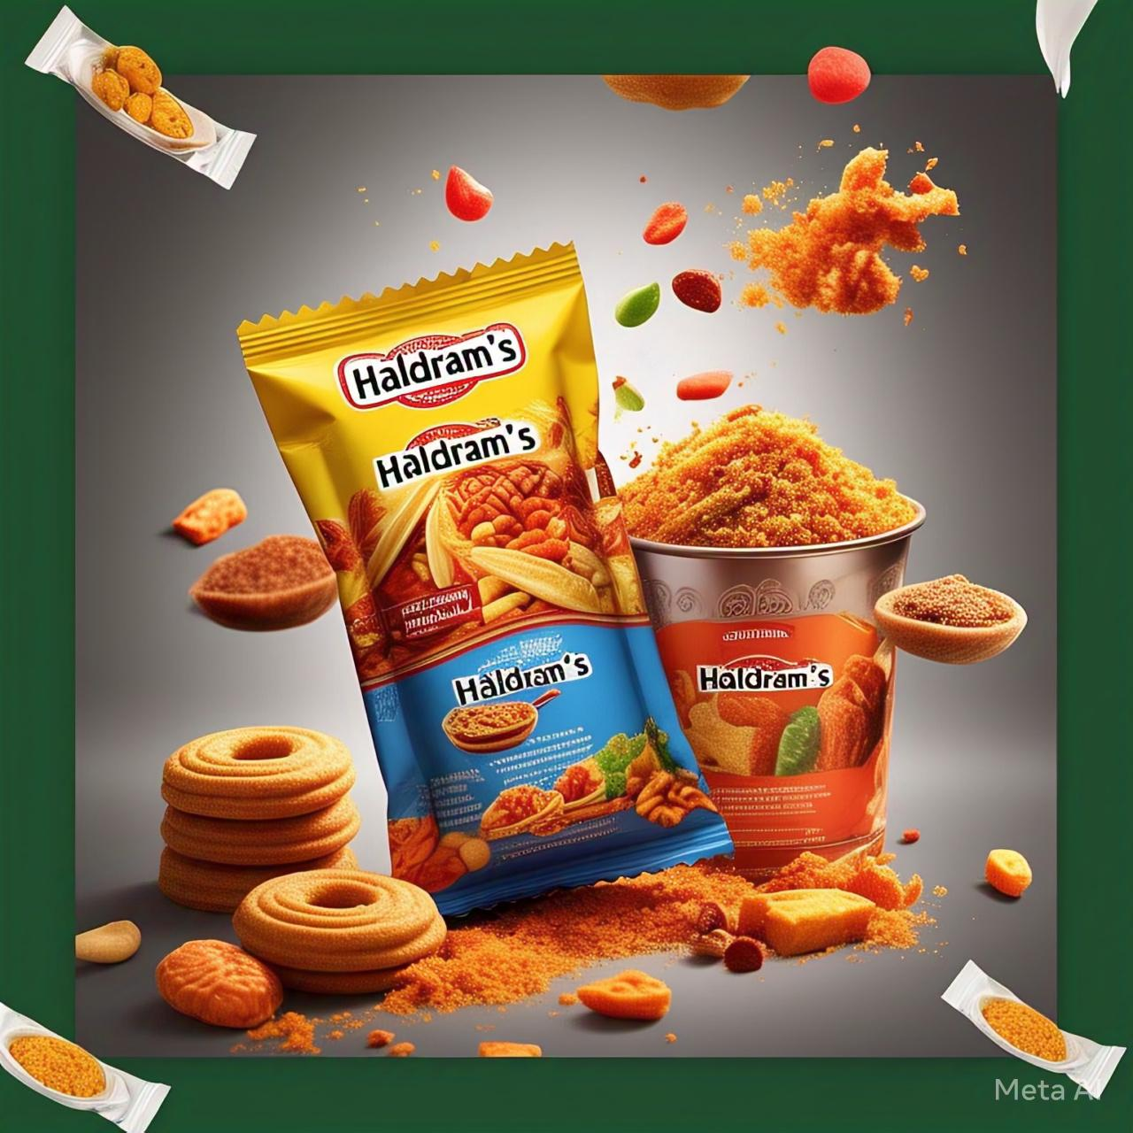

1. "Haldiram's Kitchen" series, showcasing recipes and cooking tips using Haldiram's products.

2. "The Making of" series, showcasing the manufacturing process of Haldiram's products.

3. "Haldiram's Food Stories" series, sharing stories of people who love Haldiram's snacks.

Blog Posts

1. "The History of Indian Snacks" series, exploring the cultural significance of Indian snacks.

2. "The Science of Snacking" series, sharing interesting facts and research about snacking.

3. "Haldiram's Product Reviews" series, reviewing and showcasing Haldiram's products.

Influencer and Partnership Content

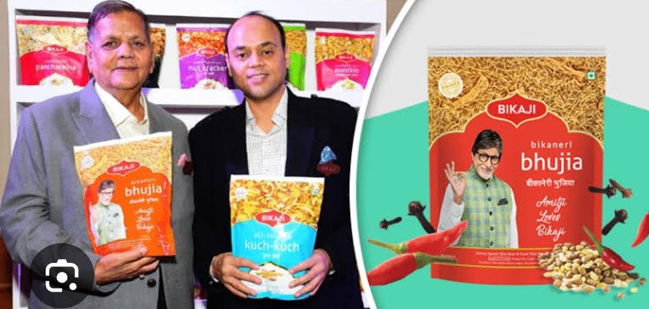

1. Collaborate with food influencers to create sponsored content

showcasing Haldiram's products.

2. Partner with Indian restaurants or cafes to create exclusive Haldiram's-based dishes.

3. Partner with wellness experts to create content highlighting the health benefits of Haldiram's snacks.

User-Generated Content Campaigns

1. "Haldiram's Snack Challenge" campaign, encouraging customers to share their favorite snack combinations.

2. "Haldiram's Recipe Contest" campaign, inviting customers to share their own recipes using Haldiram's products.

3. "Haldiram's Share Your Story" campaign, encouraging customers to share their personal stories related to Haldiram's snacks.

Gamification

1. Create a "Haldiram's Snack Quiz" game, testing customers' knowledge about Indian snacks.

2. Create a "Haldiram's Recipe Game" game, challenging customers to create new recipes using Haldiram's products.

3. Create a "Haldiram's Scavenger Hunt" game, encouraging customers to find and share Haldiram's products in their area.

Key takeaways

1.string online presence

2.engqinh content

3.influencer collaboration

4.customer engegment

5. Digital marketing strategy



I would like to express my sincere gratitude for the opportunity to work on the digital marketing project for Haldiram. Your guidance and support throughout the project were invaluable, and I appreciate the trust you placed in me.

Thank you for helping me develop my skills in digital marketing and for providing me with a platform to showcase my work.✨✨✨

Presented by Shaik Zeba Ruhi

[shaikruhishaikruhi77@gmail.com](mailto:shaikruhishaikruhi77@gmail.com)

Hall ticket no.22358014016

Vasavi Mahila Kalasala